**ECE 458**

**Spring 2020**

**Test Results**

**ECE – 6 TV Auto Commercial Mute System (MuteBot)**

**Report Submitted: March 26, 2020**

We, the undersigned, certify that we contributed to the generation of this report and attest to the validity of the data herein:

**Team Members:**

Steven Ferreira _____________________

Thomas Morrissey _____________________

Kevin Prairie _____________________

Zachary Taylor _____________________

**Customer:**

Dr. Paul J. Fortier

**Advisor:**

Dr. David P. Rancour

**Table of Contents**

Abstract 4

1 Introduction 4

2 System Overview 4

2.1 Concept of Operation 4

2.2 Functional Architecture Diagram 5

3 Customer Requirements 6

4 Engineering Requirements 7

4.1 Constraints 9

5 Standards 9

6 Resource & Cost Summary 11

7 VCRM 11

8 Test Results 12

9 Schedule 12

10 Impact Letter 14

**List of Tables**

Table 1: Customer Requirements 6

Table 2: Customer to Engineering Requirements 7

Table 3: Resources Summary & Cost 11

Table 4: Verification Cross-Reference Matrix 11

Table 5: Test Result Summary 12

**List of Figures**

Figure 1: Concept of Operation 5

Figure 2: Functional Architecture Diagram 6

# Abstract

The TV Commercial Auto-Mute system, or MuteBot, is being created to combat the initial volume spike that commercials use to quickly grab the attention of a viewer. In order to verify that all customer and engineering requirements are met, test cases have been created and will be used to test the MuteBot system. Since the Test Plan drop, nothing has changed in the design of the system, thus the team is proceeding forward in development. The team is now dealing with the new difficulties that have risen due to the coronavirus outbreak and closure of the school. Test cases that were run prior to the closure of UMASS Dartmouth have been updated with their results and the teams schedule along with new challenges for the rest of the semester have been highlighted.

# Introduction

Since the Test Plan drop, the standards have stayed the same, but the constraints have changed due to the ongoing outbreak. At this stage of the project, development and testing for the major components of the system has been continued. In order to track progress of the system and to hold the team accountable for tasks the semester schedule is still being used and updated. Since the last drop, the teams main focus has been on commercial detection with silent frames.

# System Overview

The MuteBot system diagrams are used to provide a general overview of how the system should operate. The system was broken down into different subsystems for prototyping including IR communication, commercial detection, and the physical design of the system’s housing.

## Concept of Operation

The design displayed in Figure 1 is a concept of operation. The concept of operation has remained the same. This design provides a general external overview of the project. It highlights where the system should connect into an existing entertainment center set-up as well as what each component in the system should be doing. The system is perpetually powered by a standard US 120-volt wall outlet. The system initiates when the power button on the infrared remote is pressed. Once this is activated, the MuteBot will begin running its detection algorithm. It will begin this process by taking 3.5mm audio signals and sending them to the processor for real-time processing. Once the algorithm senses what it believes to be a commercial, the MuteBot will mimic the IR mute signal of the TV brand, which will result in the TV being muted. When the MuteBot believes the TV programming has returned the MuteBot will mimic the same signal to unmute the TV.

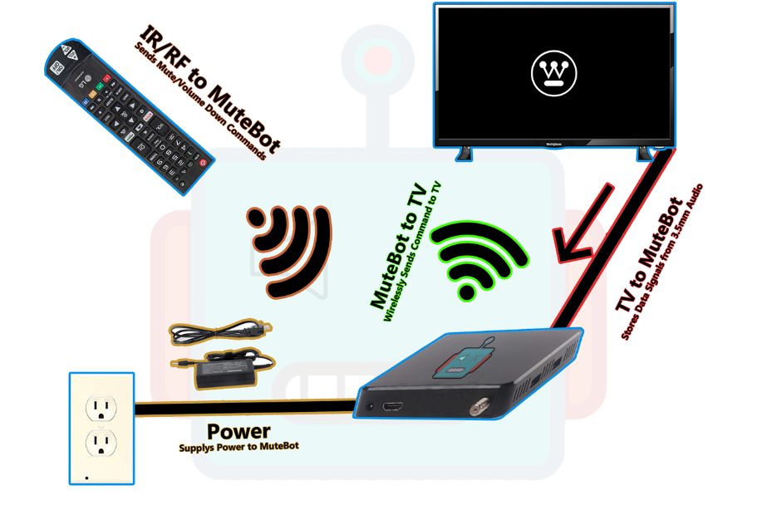

Figure 1: Concept of Operation

## Functional Architecture Diagram

In Figure 2, a functional architecture diagram is used to give a full overview of the subsystems and components that will make up the full MuteBot system. The full system has been broken down into 3 main categories: Signal Processing & Volume Control, Mounting System, and the Remote Control. Within each subsystem includes different components and aspects needed to meet the customer requirements for the system. There have been no changes to the functional architecture diagram.

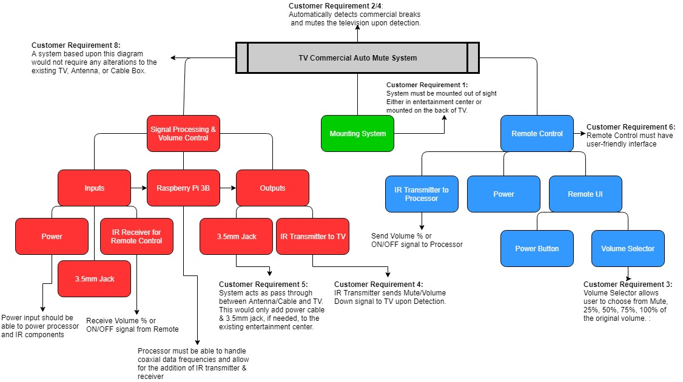

Figure 2: Functional Architecture Diagram

# Customer Requirements

Table 1 provides the customer requirements for the MuteBot system. After proposing some changes to Dr. Fortier, some of the customer requirements have changed. In order to take advantage of some of the audio cues, it has been negotiated that the commercial detection program must detect a transition within one second of the transition. Changes to the customer requirements are highlighted below in Table 1.

Table 1: Customer Requirements

|  |  |
| --- | --- |
| Customer Requirement Number | Requirement Description |
|  | System must not obstruct the TV Screen. It must be able to be kept out of sight. |
|  | System must react to a commercial break within 1 second for improvement of accuracy. |
|  | System must allow user to choose to mute completely or lower volume by a set amount when a commercial is detected. |
|  | System must mute or lower volume upon break and unmute or return to original volume upon return. |
|  | System must be simple to initially set up. |
|  | System must have a user-friendly interface/remote. |
|  | System cost must be competitive with competition. |
|  | System must refrain from any alterations to the TV or its remote control. |

# Engineering Requirements

Table 2 takes the customer requirements described in Table 1 and breaks them down into quantifiable and testable engineering requirements. Such as with the customer requirements, engineering requirement 2 and 3 have been revised to reflect the discussion the team had with Dr. Fortier. The questionnaire created for user-review tests has also stayed the same since the last report and can be found in the team’s folder.

Table 2: Customer to Engineering Requirements

|  |  |  |  |  |
| --- | --- | --- | --- | --- |
| Rqmt. # | Customer Requirement | Engineering Requirement | Justification/Comments | Test Method (IADT) |
|  | System must not obstruct the TV screen. It must be able to be kept out of sight. | System can have a cable box at most, rest of system must remain behind the TV. | The system must not be obtrusive to ensure the user has a clear and not obstructed viewing experience. | Inspection:  User-Review/Observation  This will be measured via a questionnaire. Any category in the questionnaire labeled 3 or lower will be deemed not acceptable and the next step for improvement. |
|  | System must react to a commercial break within 1 second for improvement of accuracy. | System must mute to 0 dB within 1 second of a commercial break | The system must mute preemptively in order to ensure a smoothing viewing experience for the user. | Test:  Use Audacity or other audio editing program to measure average decibel value over a time sample of 1 minute and time passed before mute was engaged. |
| 2.1 |  | System must lower volume 10 units lower within 1 second of a commercial break | The system must abide by the user’s selection. | Test:  Use Audacity or other audio editing program to measure average decibel value over a time sample of 1 minute and time passed before mute was engaged. |
| 2.1 |  | When returning from break the TV must return to the original dB volume before the commercial break within 1 second of returning to the live show | The system shouldn’t alter the original programming at all as that is not the intent of the system and not preemptively returning the volume will result in a disturbance in the user’s experience. | Test:  Use Audacity or other audio editing program to measure exact decibel value and time passed after mute was disengaged. Measure average decibel value over a time sample of 1 minute after disengagement to ensure volume returned to original value. |
|  | System must allow user to choose to mute completely or lower volume when a commercial is detected. | The system must have a user interface that enables the user to choose between a volume of 0% (mute), or a volume 10 units lower than the original volume | Giving options to the user allows for a more customizable experience. | Test & Demo: |
|  | System must mute or lower volume upon break and unmute or return to original volume upon return. | System must lower the TV to 0 dB | The mute system is to ensure the user comfort by allowing the manipulation of volume. | Test & Demo:  Use Audacity to ensure the average decibel value over 3 minutes is 0 dB. |
| 4.1 |  | If lower volume is chosen the system must lower the TV’s volume by the percent chosen by the user. | Same as above. | Test & Demo:  Use Audacity to ensure the average decibel value over 3 minutes is the chosen value less than the measured programming volume. |
|  | System must be simple to initially set up. | The engineers are only to assume the users know how to: plug in an HDMI cord, | If the system is similar to design to a TV, then the user will find it easier to work with something of similar design. | Inspection/Analysis:  User-Review/Test Subject  This will be measured via a questionnaire. Any category in the questionnaire labeled 3 or lower will be deemed not acceptable and the next step for improvement. |
| 5.1 |  | Power Cord, | Same as above. | Same as above |
| 5.2 |  | Interface with a TV remote | Same as above. | Same as above |
|  | System must have a user-friendly interface/remote. | The user interface must not consist of anything that would not already be on a TV remote or cable box. | A simple user interface allows ease-of-use and broadens the potential consumers. | Inspection/Analysis:  User-Review/Test Subject  This will be measured via a questionnaire. Any category in the questionnaire labeled 3 or lower will be deemed not acceptable and the next step for improvement. |
|  | System cost must be competitive with competition. | The system must remain anywhere from $40 - $100 retail cost. | A low retail costs attracts more customers and makes the product more able for mass production. | Analysis:  Components and materials cost will be analyzed using Excel. The final product will be compared to competition (MuteMagic, MuTR) |
| 7.1 |  | Thus, the manufacturer cost is estimated to be between $24-$67. | A lower manufacturer costs aims for a larger profit. | Analysis:  Same as above. |
| 8. | System must refrain from any alterations to the TV or its remote control. | The TV and remote must remain the same as originally purchased. | Altering the TV or remote would require too much of the user and is not fit for mass production. | Inspection:  User-Review  This will be measured via a questionnaire. Any category in the questionnaire labeled 3 or lower will be deemed not acceptable and the next step for improvement. |

## Constraints

The list below shows the seven constraints for the MuteBot system. The constraints have not been changed, but as the team progresses throughout the semester, any updates or changes will be highlighted.

1. Form Factor (Same size or smaller than an Apple TV or Roku Ultra)

* Apple TV: Height-1.4 in, Width-3.9 in, Depth-3.9 in
* Roku Ultra: Height-0.8 in, Width-4.9 in, Depth-4.9 in

1. TV cannot be altered or changed in any way (Removing or modifying parts or remote)
2. Location- should not be visible (mounted to the back of the TV)
3. Inputs on the TV (HDMI, coax)
4. Outputs on the TV (Digital Optical Audio cable, 3.5mm Jack)
5. Budget-must be in same price range as the competitors (MuteMagic $39.95, MUTR $30 with a subscription of $50 per year)
6. Television provided (Westinghouse HDTV)
7. The ongoing outbreak of COVID-19 has disrupted the timing, resource availability, and meeting availability for the team. Section 10 provides a greater detailed impact on the rest of the semester.

# Standards

The standards for the Mutebot system have not been changed. The list below shows the current standards for the system, but as we progress throughout the semester and conduct more prototyping, these standards may be updated and will be highlighted.

1. CALM Act: Commercial Advertisement Loudness Mitigation Act:
   1. <https://www.provideocoalition.com/the-calm-act-commercial-advertisement-loudness-mitigation/>
   2. The FCC set and monitor the loudness of commercials. The ITU, International Telecommunication Union, created standard audio measurements for content that is being broadcasted
2. ITU-R BS.1170:
   1. <https://www.itu.int/dms_pubrec/itu-r/rec/bs/R-REC-BS.1770-4-201510-I!!PDF-E.pdf>
   2. Ways to measure commercial audio loudness and true-peak audio level
3. IEEE Code of Ethics
   1. <https://www.ieee.org/about/corporate/governance/p7-8.html>
   2. The responsibilities in which all engineers are expected to follow that are expressed in a code of ethics.
4. Betamax Case: Sony Corp. of America v. Universal City Studios, Inc.
   1. <https://www.oyez.org/cases/1982/81-1687>
   2. Ruled recording TV legal
5. Copyright Laws and Television:
   1. <https://yourbusiness.azcentral.com/copyright-laws-television-16286.html>
   2. TV cable programs have copyrights to a program that can be violated (file sharing and sales, dependent on each program)
6. HDMI Specification Version 1.4a
   1. https://www.hdmi.org/manufacturer/hdmi_1_4/index.aspx
   2. HDMI standards and specifications that define the required waveforms and video format.
7. American National Standard ANSI/SCTE 07 2006, American National Standard ANSI/SCTE 124 2006
   1. <https://www.scte.org/documents/pdf/Standards/ANSISCTE072006.pdf>
   2. Digital Transmission Standard for Cable Television
   3. <https://www.scte.org/documents/pdf/Standards/ANSISCTE1242006.pdf>
   4. Specifications and standards for the F type connector used for cable television
8. ITU-T L.1002 (10/2016)
   1. https://www.itu.int/itu-t/recommendations/rec.aspx?rec=12131
   2. Standards for external universal power adapters
9. Standard IEC958
   1. Digital audio interface, standard for digital optical audio cables
   2. <http://www.epanorama.net/documents/audio/spdif.html>
10. TRRRS Standards including P.382
    1. Standards for the 3.5mm connector
    2. P.382 TRRRS connectors for new integration including multiple sources and noise canceling
    3. https://www.itu.int/itu-t/workprog/wp_item.aspx?isn=9990
11. Infrared Data Association (IrDA)
    1. Standards and specifications for IR transmitter and receiver communication
    2. <https://www.novell.com/documentation/suse91/suselinux-adminguide/html/ch08s03.html>
12. IEEE 802.15.4-2015 - IEEE Standard for Low-Rate Wireless Networks
    1. Standard for RF modules including the 3 pin RF module
    2. Short range devices have unlicensed ISM/SRD bands like RF remotes
    3. <https://standards.ieee.org/standard/802_15_4-2015.html>

# Resource & Cost Summary

Table 3 provides an overview of the resources and cost for the MuteBot system. The resource summary and cost has not changed. As the team continues to work towards the final product, any new components or purchases will be highlighted in future reports.

Table 3: Resources Summary & Cost

|  |  |
| --- | --- |
| Resource | Cost |
| Raspberry Pi 3 | $38.36 |
| Geekworm Raspberry Pi IR remote expansion board | $12.09 |
| Sabrent USB external stereo sound adapter | $6.99 |
| Energizer 2025 Lithium Battery | $7.43 |
| Sandisk Ultra Plus 16G GB microSD card | $10.61 |
| HDMI to VGA adapter | Supplied by UMASS Dartmouth |
| LIRC (IR communication software) | Free software |
| 5V DC Power supply | $9.00 |
| Coax cable | $4.82 |
| 3.5mm jack | $6.99 |
| Westinghouse HDTV & Remote | Provided by customer |
| TV Antenna | Provided by customer |
| HDMI Cable | Supplied by customer |
| 3D Printer | Supplied by Umass Dartmouth |
| Atmel Studio 7.0 | Software provided by UMASS Dartmouth |
| Audacity | Free software |
| Solidworks | Free software |
| Total | $96.29 |

# VCRM

Table 4 provides a verification cross-reference matrix in order to highlight the different verification methods being used to verify each of the engineering requirements for the system.

Table 4: Verification Cross-Reference Matrix

|  |  |  |  |  |  |  |
| --- | --- | --- | --- | --- | --- | --- |
| Customer Requirement | Engineering Requirement | Inspection | Analysis | Demonstration | Test | Comments |
| 1 | 1 | **X** |  |  |  |  |
| 2 | 2 |  |  |  | **X** |  |
|  | 2.1 |  |  |  | **X** |  |
|  | 2.2 |  |  |  | **X** |  |
| 3 | 3 |  |  | **X** | **X** |  |
| 4 | 4 |  |  | **X** | **X** |  |
|  | 4.1 |  |  | **X** | **X** |  |
| 5 | 5 | **X** | **X** |  |  | Analysis will be derived from the questionnaire |
|  | 5.1 | **X** | **X** |  |  |  |
|  | 5.2 | **X** | **X** |  |  |  |
| 6 | 6 | **X** | **X** |  |  |  |
| 7 | 7 |  | **X** |  |  |  |
|  | 7.1 |  | **X** |  |  |  |
| 8 | 8 | **X** |  |  |  |  |

# Test Results

In total the team has created six test cases to cover all aspects and requirements of the MuteBot system. As the semester progresses and if the team feels as though more tests are needed or more steps are required to complete a test, then new test cases will be created or revised. Test Results can be found in the submissions folder under “ECE-6 Test Results”. Table 5 provides a summary of the test cases that have been run thus far and their results. Further details for each test can be found in their respective test results document.

Table 5: Test Result Summary

|  |  |  |  |
| --- | --- | --- | --- |
| Engineering Requirement # | Test Number | Pass/Fail | Comments |
| 5, 5.1, 5.2 | 1 | Incomplete | *See Test Results 1 (Setup)* |
| 3, 6 | 2 | Pass | *See Test Results 2 (System Remote)* |
| 2, 2.1, 2.2 | 3 | Fail | *See Test Results 3 (Commercial Detection)* |
| 3, 4 | 4 | Fail | *See Test Results 4 (TV Remote)* |
| 1, 6, 8 | 5 | Incomplete | *See Test Results 5 (Enclosure)* |
| 7, 7.1 | 6 | Incomplete | *See Test Results 6 (Cost Analysis)* |

# Schedule

As the semester has progressed, the team has updated the semester schedule to include the task start date, end date, and hours worked on. The teams updated progress can be found in the submission folder under “ECE-6 Test Results”.

# Impact Letter

The impact of COVID-19 hasn’t severely set back our schedule. However, it is projected to greatly impact the future of this project. Over the previous two weeks the team has visited the labs over the break to work on the prototype, but due to the closure of the labs the team has not been able to continue. The materials are still in the lab making all future testing and plans unknown currently. Prior to the shutdown, the team could detect a break to a commercial and a return to television programming, but it was very inconsistent. It also detected a wide range of false positives. The plan was to correct this when class sessions resumed, but this is no longer an option.

Due to state lockdown procedures, the group has not been able to meet physically. However, the team continues to communicate via a software called Discord and Zoom to share ideas and future prospects. Productivity has greatly decreased due to the lack of available equipment. The overall goal is to pick up the materials for this project at a further date past April 7th, but backup plans are still being made regardless. The team currently is reworking the project to still meet customer requirements without physical hardware. The current plan is to create test footage using Adobe Premiere then create a program that detects breaks with that footage. However, this is far from ideal as it lacks the practicality the original proposal had.

Some members of the group also lived on-campus, which allowed for easy group meetings at any time in the lab. The above proposal also requires a near complete restart of the design as the original program specifically worked for real-time streaming. The prototype still has many features that have to be tested and implemented. If the team can access the materials, the team will continue the prototype at the team-leads house while following CDC guidelines on the virus. However, this only applies to members of the group that are local. Those that are not able to get transportation to and from the team lead’s house will be given aspects of the project that do not require the materials.

Overall, the team is not letting COVID-19 disrupt the end goal of this project. However, the original plans will have to be altered. Following this report, the team will stay in constant communication with Dr. Fortier to ensure the project is of quality.